PPC Getting Started Guide

Prerequisites:

1. Q-account in the peas.publix.com domain.

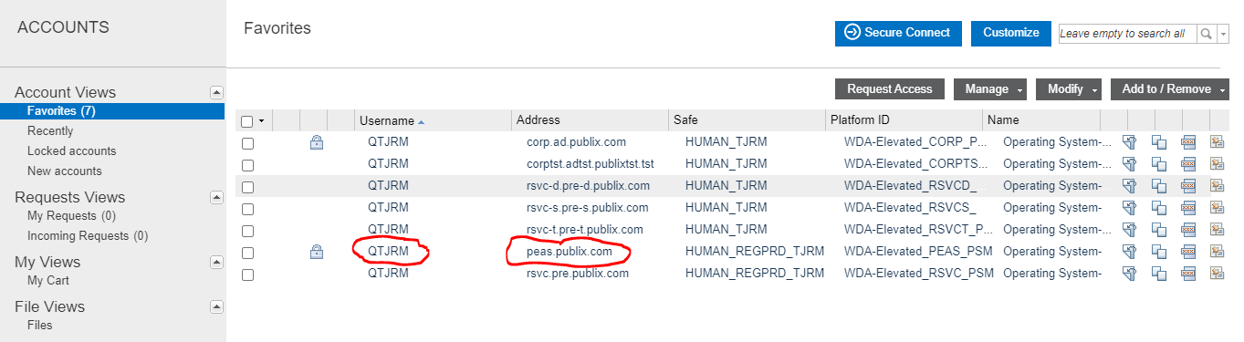

1. Q-account access into the peas.publix.com domain VMware environment(s).

Logging in:

1. Log into Cyber-Ark.
2. Make note of your peas.publix.com domain q-account password (this will be needed later).
3. Click on the “Action menu” icon then select “Connect with” in drop down then select “RDP”.
4. In the “Connect with Account” window enter one of the following jump servers in the “Remote Machine:” field and click “OK”.
   1. A46PRDSHPEASA01.PEAS.PUBLIX.COM
   2. L17PRDSHPEASA01.PEAS.PUBLIX.COM
5. The following warning box may pop up. Click “Yes” to continue.

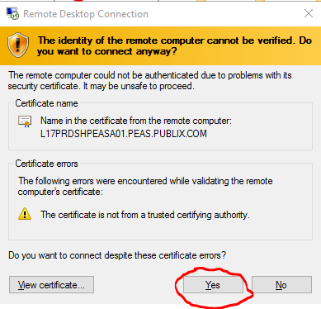

1. Once logged in open a web browser.
2. Go to the following URL:
   1. <https://pvavra01.publix.com/>
3. Click on the “GO TO LOGIN PAGE” button
4. Login with your peas.publix.com domain q-account and password obtained in step 2.
5. The page should look similar to the following but may differ slightly depending on permissions.

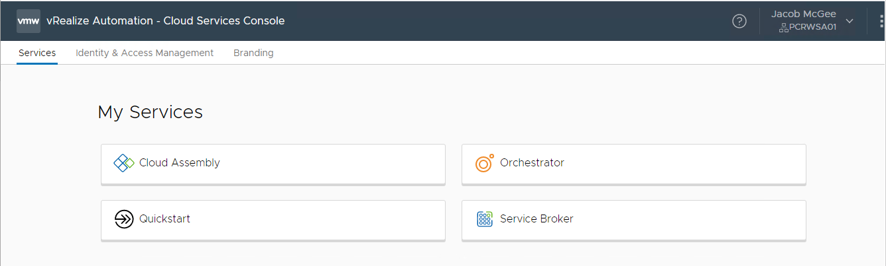

Building a system:

1. In the “Services” tab click on “Service Broker”.

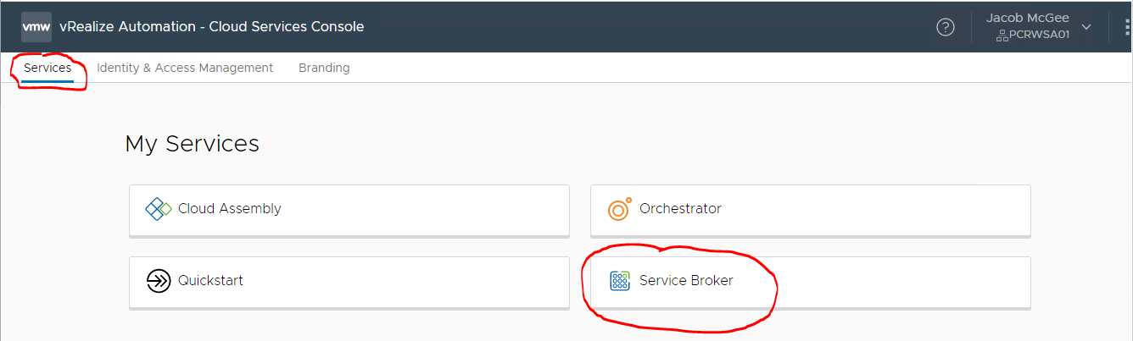

1. In the “Catalog” tab click on the “REQUEST” link in the “Linux 1 group” Catalog Items.

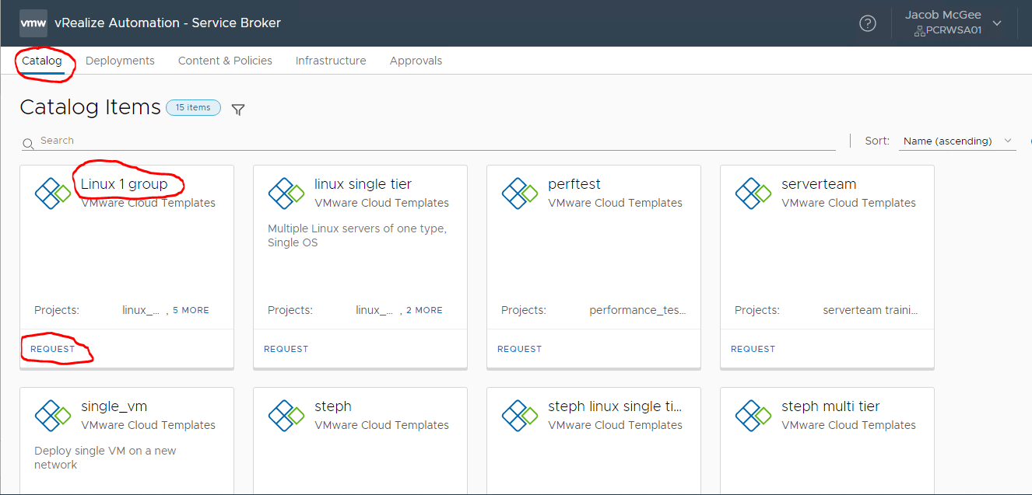

1. Populate the following fields in the General tab:
   1. Deployment Name: This an arbitrary but is required to maintain the build.
   2. Project: For the purposes of a Unix team system build use one of the following.
      1. system engineering non-production
      2. system engineering production
   3. systemid: This is specified in the TDD.
   4. Description: This populates the Description field in the CMDB
   5. Lifecycle: One of the following. This is specified in the TDD.
      1. development
      2. test
      3. staging
      4. production
   6. AD domain: corp.ad.publix.com should be used but other domains may be developed in the future.
   7. Additional IPs to reserve: This field is used for addition IP if required. For Example: Needed for additional virtual NIC’s.

Note: Don’t click on the “Submit” button yet.

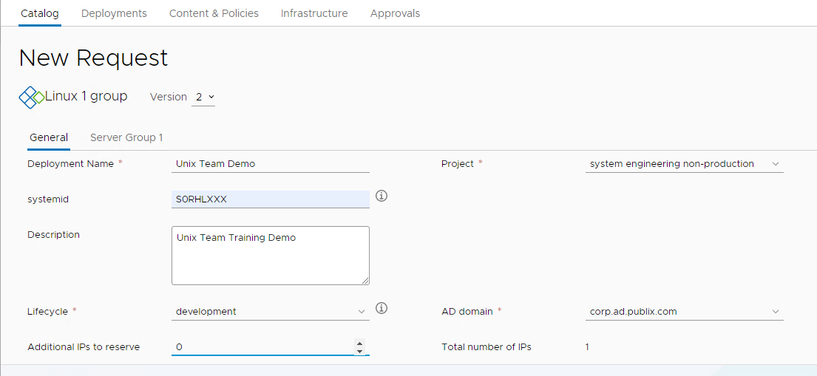

1. Go to the “Server Group 1” tab

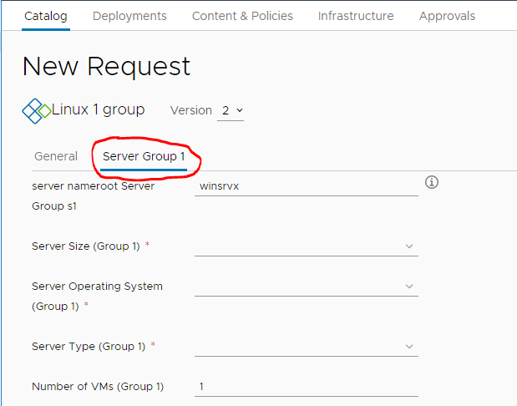

1. Populate the following fields in the “Server Group 1” tab:
   1. Server nameroot Server Group s1: This nameroot will be specified in the TDD. Note: Other letters/numbers get added to this name for a final unique actual hostname.
   2. Server Size (Group 1): This is the standard server sizes as far as CPU and memory. The follow are the options with the corresponding CPU and memory sizes. This is specified in the TDD.
      1. entry-2: 2 cpu(s), 4Gb memory
      2. entry-4: 4 cpu(s), 8Gb memory
      3. entry-8: 8 cpu(s), 16Gb memory
      4. entry-16: 16 cpu(s), 32Gb memory
      5. highcpu-2: 2 cpu(s), 2Gb memory
      6. highcpu-4: 4 cpu(s), 4Gb memory
      7. highcpu-8: 8 cpu(s), 8Gb memory
      8. highcpu-16: 16 cpu(s), 16Gb memory
      9. highmem-2: 2 cpu(s), 16Gb memory
      10. highmem-4: 4 cpu(s), 32Gb memory
      11. highmem-8: 8 cpu(s), 64Gb memory
      12. highmem-16: 16 cpu(s), 128Gb memory
      13. standard-2: 2 cpu(s), 8Gb memory
      14. standard-4: 4 cpu(s), 16Gb memory
      15. standard-8: 8 cpu(s), 32Gb memory
      16. standard-16: 16 cpu(s), 64Gb memory
   3. Server Operating System (Group 1): This is specified in the TDD
      1. Red Hat 7
      2. Red Hat 8
   4. Server Type (Group 1): This is specified in the TDD
      1. Appl Server
      2. Core Server
      3. Database Server
      4. Print Server
      5. Server
      6. Web Server
   5. Number of VMs (Group 1): The number of servers you want built. This is specified in the TDD. Note: These are all identical system based on the criteria from the input above.

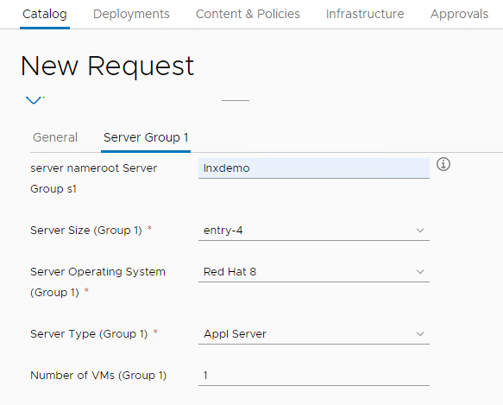

1. Click the “Submit” button to begin build.

Verification and Post build:

Much of the build takes place in prd tower. To watch and/or troubleshoot build failures login to pansia10 (PRD Tower) for details of the builds.

1. https://pansia10.publix.com/#/login/

To access the newly built server(s):

1. While logged into the jump server open a web browser
2. Go to the peas.publix.com VMware environments at the following URLs:
   1. <https://l17pnpwvca01.peas.publix.com/> for non-prod
   2. <https://a46pwvca01.peas.publix.com/> for prod